### Project Name: Sales Automobile Using Salesforce CRM

Team ID : LTVIP2024TMID11571

Team Leader : R JAHNAVI

**Salesforce**

**Creating Developer Account**

Creating a developer org in salesforce.

1. Go to <https://developer.salesforce.com/signup>
2. On the sign up form, enter the following details :

[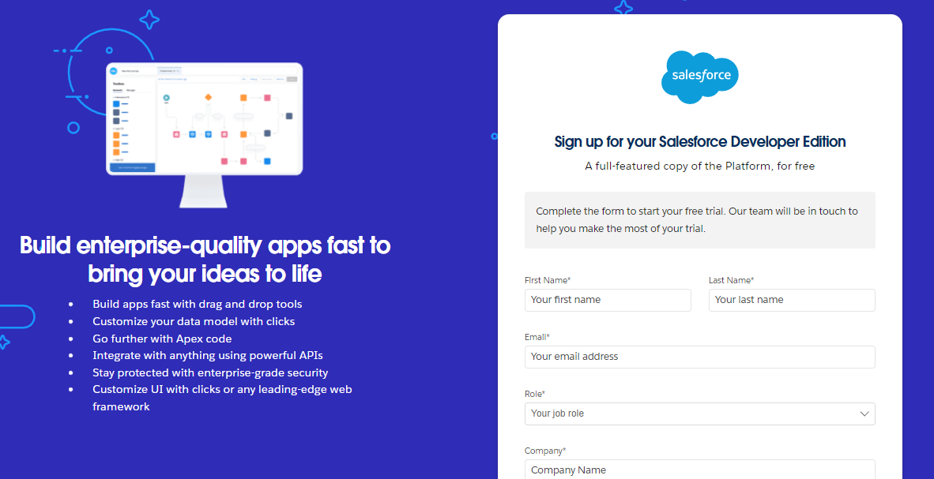](https://developers.salesforce.com/Signup*)

1. First name & Last name
2. Email
3. Role : Developer
4. Company : College Name
5. County : India
6. Postal Code : pin code
7. Username : should be a combination of your name and company

This need not be an actual email id, you can give anything in the format : username@organization.com

Click on sign me up after filling these.

### Account Activation

1. Go to the inbox of the email that you used while signing up. Click on the verify account to activate your account. The email may take 5-10mins.

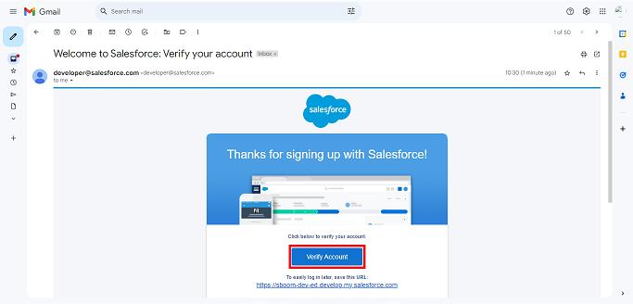

1. Click on Verify Account
2. Give a password and answer a security question and click on change password.

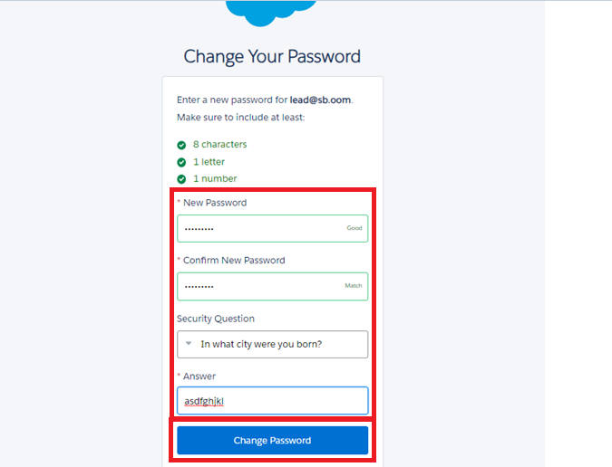

1. Then you will redirect to your salesforce setup page.

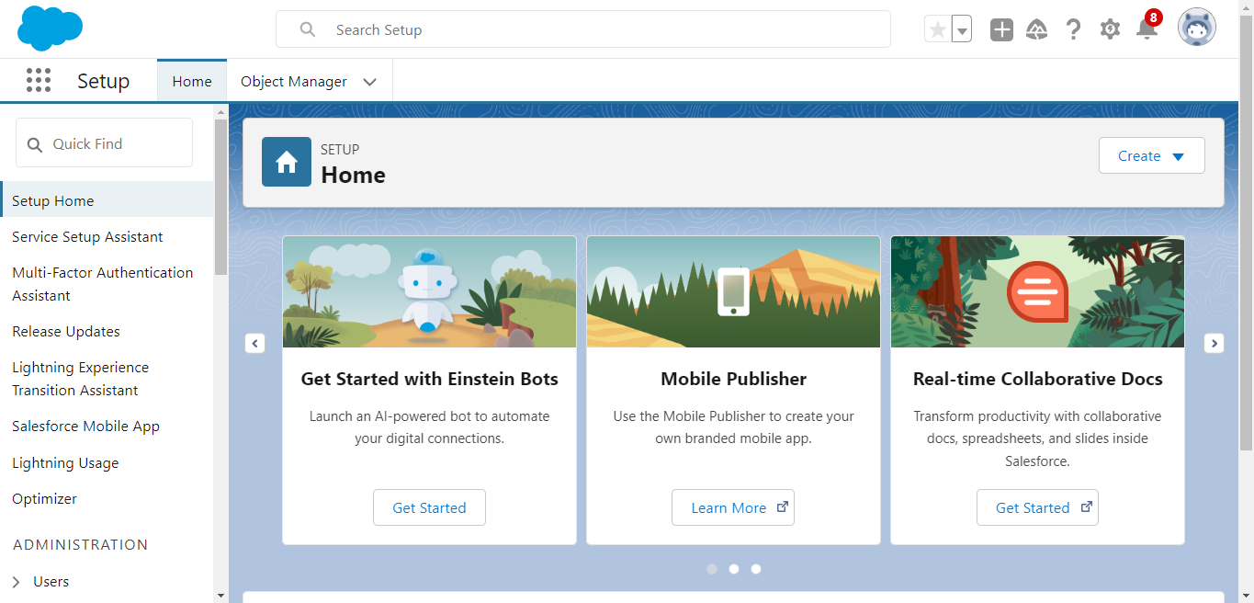

### Object

### Create Automobile Information Object

1. Download and open [this spreadsheet](https://docs.google.com/spreadsheets/d/1Ls-gXLsp8d7ikTJTo5-GlK4AbA4DjZxbFWcj1zKme4I/edit?usp=sharing), save it as AutomobileInformation.csv.
2. Make sure to download the File into CSV format.

Note : Make sure to have the name of the file as “Automobile Information”.

Log into your salesforce account, click Setup, then select Setup.

1. Click the Object Manager tab.  
   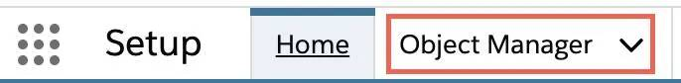
2. Click Create.
3. Select Custom Object from Spreadsheet.  
   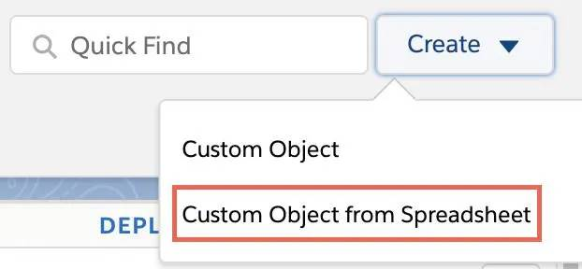
4. Click Login With Salesforce.
5. Enter your Salesforce account username and password. (which you have created in the Milestone 1, Activity 1)
6. Click Log In.
7. Click Allow.
8. Click Upload.
9. Navigate to the Automobile Information.csv file you downloaded and upload it. Salesforce automatically detects the fields and populates all its record data. Choose the Record Name field and make sure all fields are with the proper datatypes as below as they are.

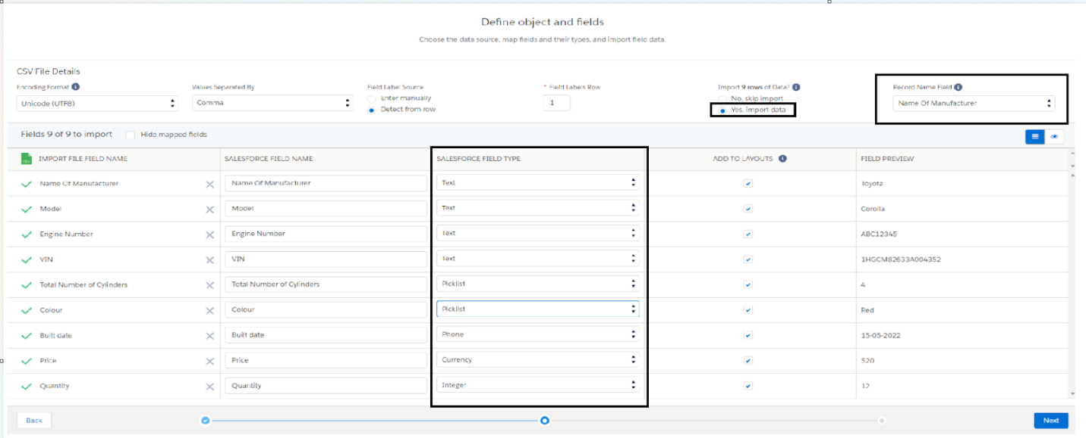

1. Click Next and enter the following settings.
2. Click Finish. The Automobile Information object is successfully created and data imported, all within minutes.

### Create Invoice Object

Create Invoice object, just as we have created an Automobile Information Object using [this sheet](https://docs.google.com/spreadsheets/d/11C59mo2WsAN5n18mn3zr-O37nJA3WHyHdB582CaFqVE/edit?usp=sharing)Make sure to Download the File into CSV Format.

Note: Make sure you do field mapping with proper field type as shown below.

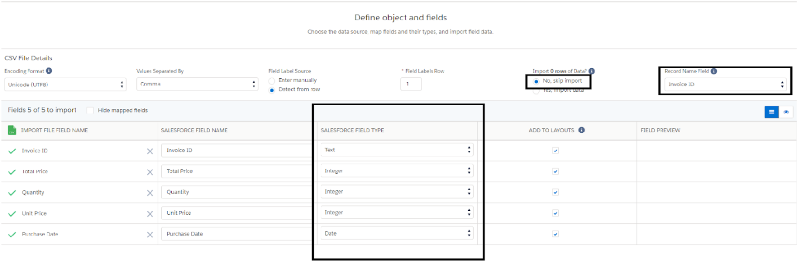

**Create Automobile Object**

The purpose of creating an Automobile custom object is to store and manage information about Invoice.

To create an object:

1. From the setup page >> Click on Object Manager >> Click on Create >> Click on Custom Object. 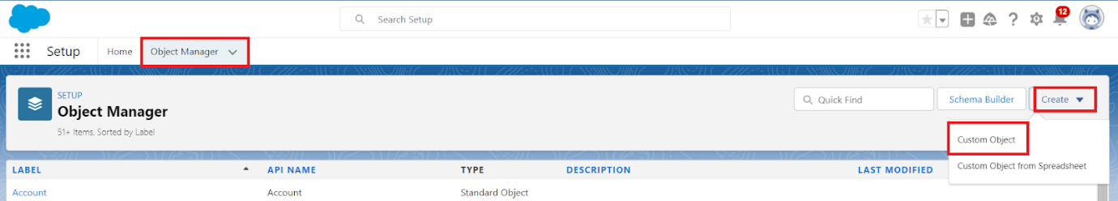

1. Enter the label name? Opportunity Automobile
2. Plural label name?Opportunity Automobiles

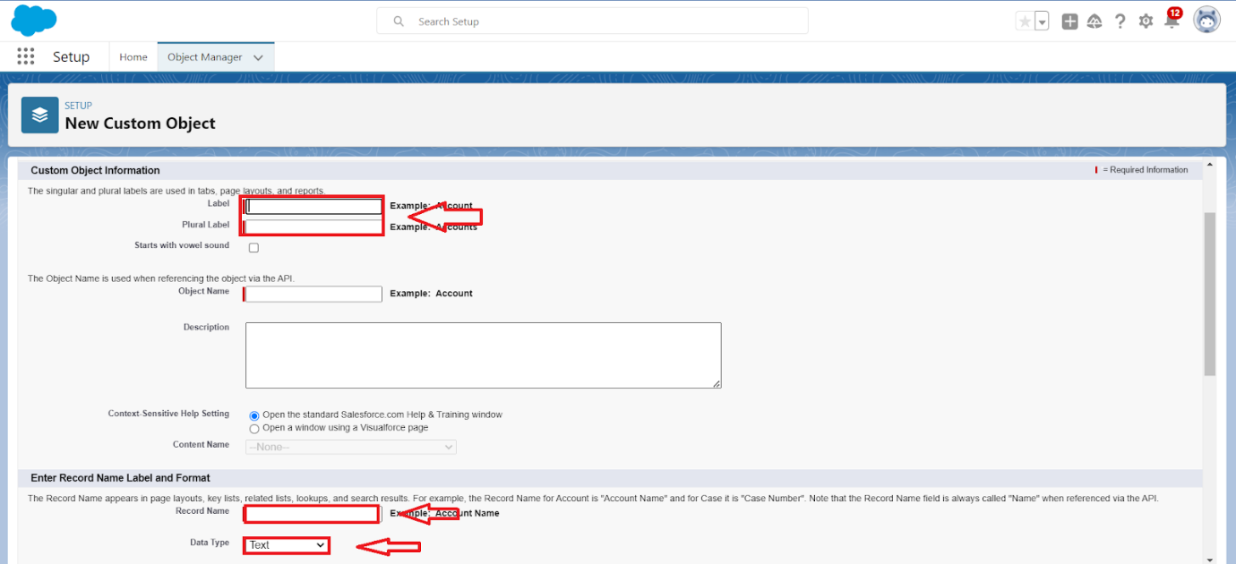

1. Enter Record Name Label and Format

* Record Name >> Opportunity Automobile Id
* Data Type >>  Auto Number
* Display Format >> OA-{0000}
* Starting Number >> 1

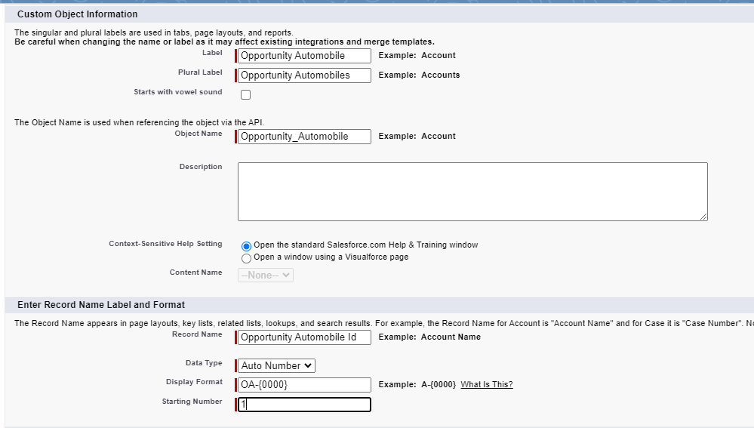

1. Click on Allow reports.
2. Allow search
3. >> Save.

**Tabs**

**Creating A Custom Tab**

1. Go to setup page >> type Tabs in Quick Find bar >> click on tabs >>  New (under custom object tab)  
   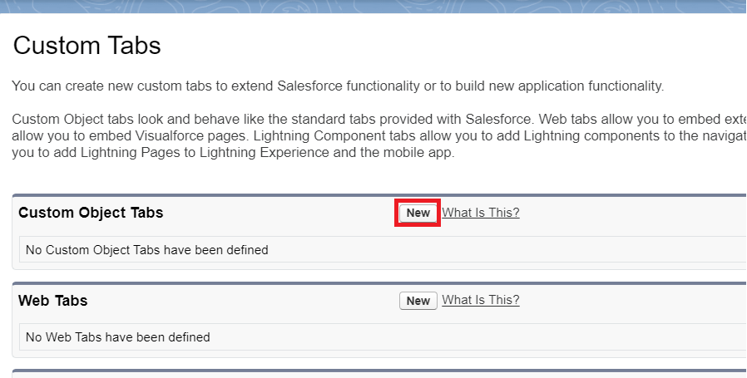
2. Select Object(Opportunity Automobile) >> Select any tab style >> Next (Add to profiles page) keep it as default >> Next (Add to Custom App) keep it as default >> Save.  
   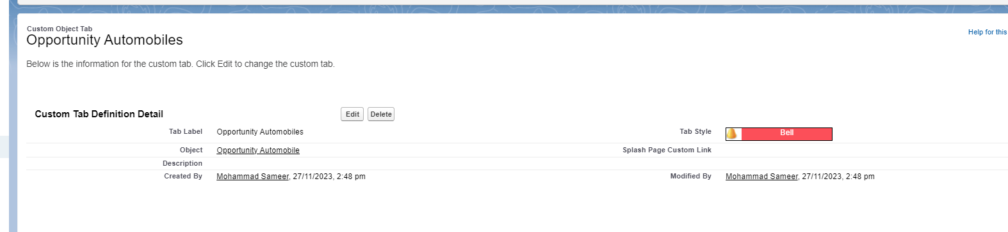

Note: Tabs for Automobile Information & Invoice objects do get created automatically. We do not need to create tabs for those objects.

### The Lightning App

### Create A Lightning App

1. Go to setup page  >>  search “app manager” in quick find >>  select “app manager”  >> click on New lightning App.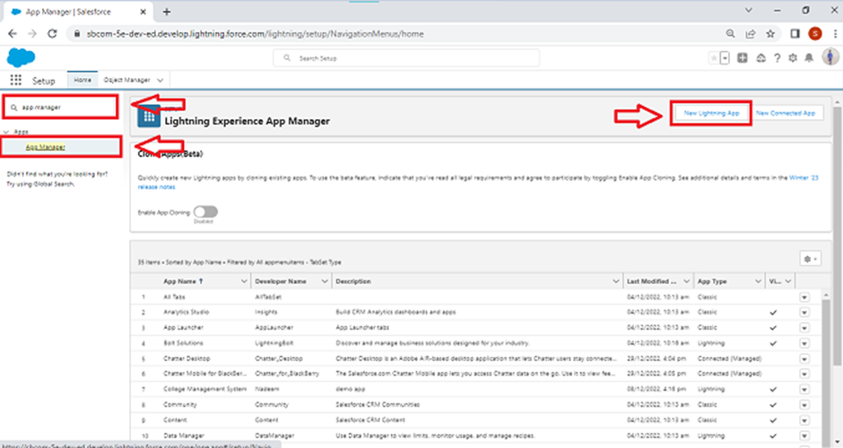
2. Fill the app name in app details and branding as follow
   1. App Name :Sales Automobile Using Salesforce CRM
   2. Developer Name : this will auto populated
   3. Description : Give a meaningful description
   4. Image : optional (if you want to give any image you can otherwise not mandatory)
   5. Primary color hex value : keep this default
3. Then click Next  >>  (App option page) keep it as default >> Next  >> (Utility Items) keep it as default >> Next.  
   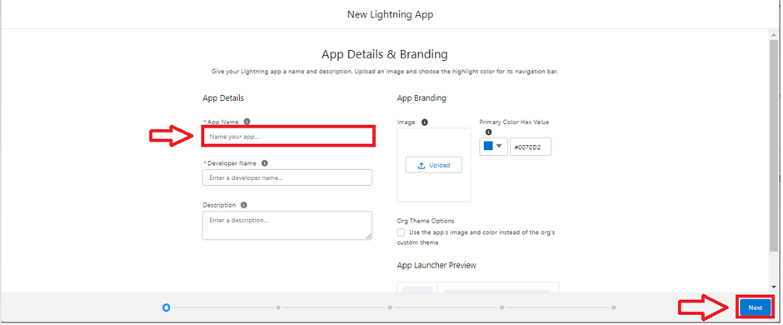
4. Add Navigation Items:  
     
   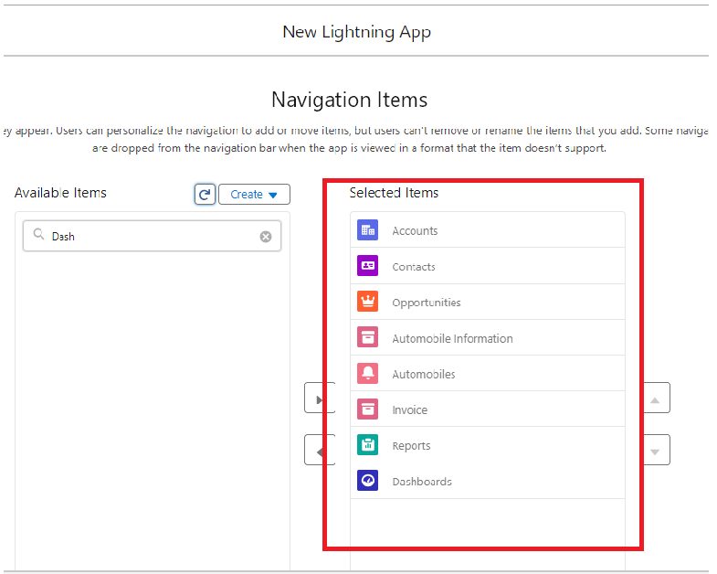
5. Search the items in the search bar(Account,Contact ,Opportunities,Automobile Information,Opportunity Automobile,Invoice, Reports, Dashboard) from the search bar and move it using the arrow button ? Next.  
   Note: select asset the custom object which we have created in the previous activity.

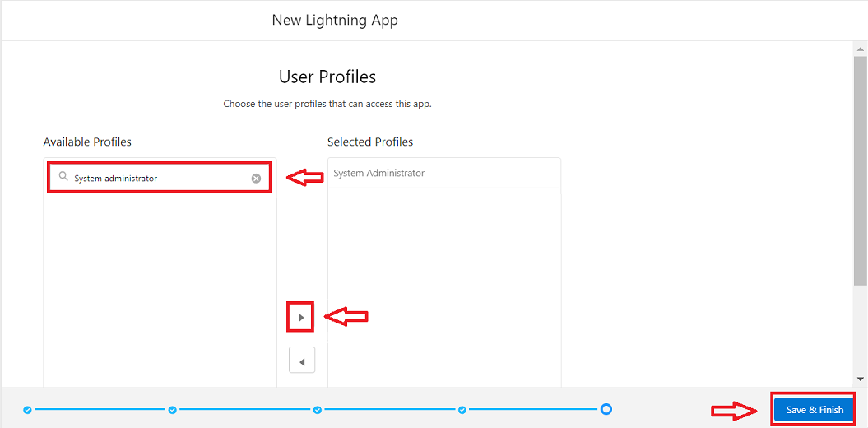

1. Search profiles (System administrator) in the search bar >>  click on the arrow button >> save & finish.